







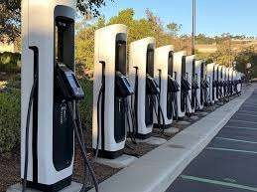
P RO F I L E

R . D. T E C H I NF R A

M U R A L I N I K E TA N , S 2 - K 2 / 3 2 6 , I N D R A N A G A R ,

L U C K N O W 2 2 6 0 1 6 - UP

M o b : 7 5 7 1 0 0 4 6 1 0 , 7 5 2 6 0 0 4 6 1 0

e m a i l : p r o j e c t r d t e c h i n f r a @ g m a i l . c o m

I N T R O
Construction Industry inevitably plays a very important role in the development of a Country. A good highway system is considered to be the most important attribute for the Industrial Development of a Country. Keeping in view the
Importance of the Construction sector in shaping the socio-economic face of a country as also various development programs of the Central Government and the State Governments, R.D. Tech Infra a Proprietor ship Business was set up by Santosh Kumar Pandey in 2023.

R.D. Tech Infra brings together best of breed technologies in the telecom and enterprise domains to address clients’ critical business needs. R.D. Tech Infra has a group of expert professionals who specialize in the execution of contracts and have the ability to respond to the most demanding challenges.
P R E S E N T A T I O N T I T L E
R.D. Tech Infra comprehensive portfolio of services is aligned across its business, e.g. Security services. A brief on the “Security” services within the “Government & Corporate” stream is detailed below.
2



R.D. Tech Infra brings together best of breed technologies in the telecom and enterprise domains to address clients’ critical business needs. R.D. Tech Infra has a group
of expert professionals who specialize in the execution of contracts and have the ability to respond to the most demanding challenges.

R.D. Tech Infra comprehensive portfolio of services is aligned across its business, e.g. Security services. A brief on the “Security” services within the “Government & Corporate” stream is detailed below.

Our Business Division
(Operation & Maintenance)

Our Service
Offerings
Telecom Security & Maintenance







NETWORK ENGINEERING

SERVICE ENGINEERING

TECHNICAL SQUAD

E.V. CHARGING POINT

TOWER ERECSSION

Our commitment to the Service sector is also demonstrated by our substantial investment in the latest technology for better services,
In addition of Telecom Testing and Commissioning of both GSM and CDMA Networks enabling us to execute the projects with the highest level of efficiency.

P R E S E N T A T I O N T I T L E
4

GENERAL
 | : R.D. TECH INFRA
Name
Corporate Office | :  : MURALI NIKETAN,S2-K2/326 ,INDRA NAGAR  LUCKNOW - 226016
Telephone | : | 7571004610,752  6004610
E-Mail | : | projectrdtechinfra@gmail.com

GENERAL
Name

Corporate Office

: R.D. TECH INFRA
:
: MURALI NIKETAN,S2-K2/326 ,INDRA NAGAR
LUCKNOW - 226016

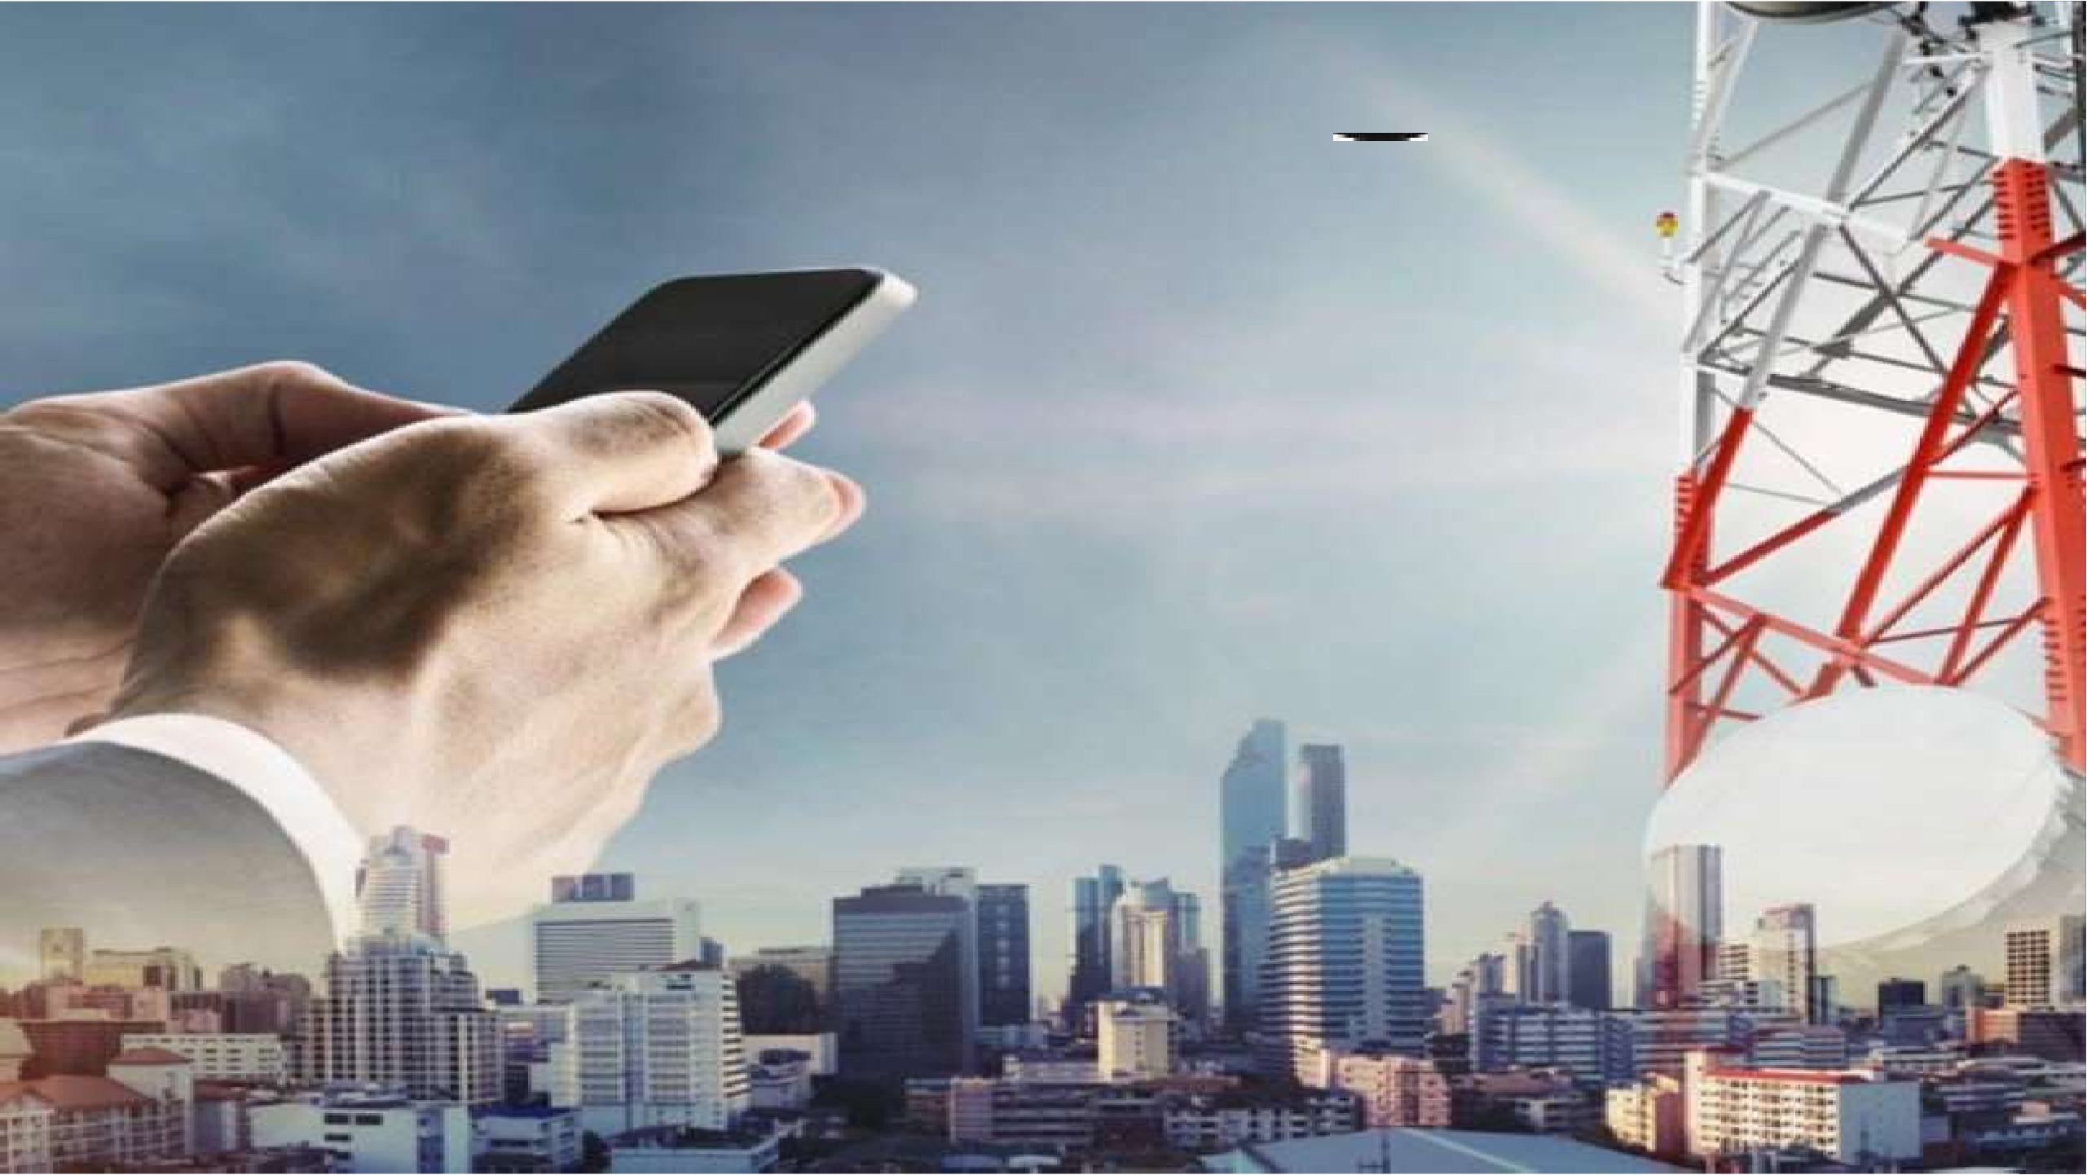
Telephone E-Mail : 7571004610,7526004610
: projectrdtechinfra@gmail.com

OUR ORGANIZATIONAL BRIEF

Year of Commencing Business | : | 2023
PAN No. | : | ZVPP4668E1ZJ
Labor Reg. No | ` : | UPS147006000516
EPFS No. | : | UP/VNS/59261
ESIC NO. | : | 28000506820001009
Contact Person | : | Santosh Kumar Pandey
Designation | : | PROPRIETOR
Contact Number | : | 7571004610,7526004610






Services Offered For Telecom Sector:
Services offered are as under:-

- TSP Solution.
- O&M Services.
- E.V. Charging point
- E.B Maintenance.
- OFC Laying Work.
- OFC Maintenance.

Network engineering

Network Engineering (NE) Group, at R.D. TECH INFRA,is a leading provider of multi-vendor solutions in the telecom infrastructure services market. NE services cater to major OEMs, Network operators and large utilities, across the life cycle of the Network rollout. The services offered include custom network design, network installation and commissioning services, and outsourcing of procurement and logistics. We work in partnership with leading industry suppliers to deliver end-to-end telecom engineering solutions.

R.D. TECH INFRA -NE serves as a vital link between OEMs and Operators leveraging on the expertise available with it to plan, rollout, improve and upgrade telecom networks for its customers. serves the Telecom Infrastructure services Industry. With the quality of deliverables, resulting in satisfied customers. Our business has continued to develop in India. With its domestic headquarters based in Uttar Pradesh (India), Apart from the regional offices NE operates from branch offices and projects offices established on need basis to facilitate project co-ordination & execution activities.





Infra Capabilities

In today’s competitive cellular services market, the operators & OEMs are becoming more and more concerned about the quality of their
existing networks while trying to expand with ease at the same time.

They are in need of a partner, a specialist who can design, deploy, monitor, benchmark and optimize their networks so that they can focus on their core activities.

The Network Engineering (NE) team of R.D. TECH INFRA has a strong team of Engineers who can provide Infra Works and BTS
Installation & Commissioning related services.

R.D. TECH INFRA -NE serves as a vital link between OEMs and Operators leveraging on the expertise available with it to plan, design and implement the civil infrastructure and the Electrical Indoor & Outdoor works for its customers. R.D. TECH INFRA believes in partnering with its customers to add value and work productively towards achieving the goals.

Shelter, Civil & Electrical Infrastructure

R.D. TECH INFRA offerings in this domain can be grouped under the following headings:

- Site Acquisition

R.D. TECH INFRA has employed people who can acquire the sites based on the guidelines by the Operator. This is the most preliminary process in the infra rollout. The sites have to be cleared on the legal guidelines set by the operator. Various aspects are vetted that would make the site feasible for building. Also the electricity power required to operate the equipments should be easily made available.

- Site Permissions
R.D. TECH INFRA has Liaisioning officers who work with the various government bodies to acquire the necessary permissions. The
permissions may include:

- Municipal Authority / Local Authority
- Electricity Board
- Pollution Board





- Site Design
R.D. TECH INFRA engineer will make a preliminary site layout depicting the positioning of shelter, tower, DG, earth pits etc., based on whether it is a RTT or a GBT site .
Structural stability of the building or soil testing is carried
out. The foundation designs are then prepared for the Tower, Shelter and the DG.
The electrical specifications are mostly fixed by the operators the same is vetted and changes if any are suggested to the customer
- Site Build

R.D. TECH INFRA employs qualified civil engineers who monitor the quality and the pace of the foundation works. This will ensure error free foundations and will avoid
reworks which consume lot of project time. R.D. TECH INFRA has a quality check list for the activity and the same is maintained for each and every site executed.
R.D. TECH INFRA also supplies quality shelters having very low cost and consuming less of power saving electrical & DG load. The insulation of Polyurathene gives longer life to the shelter.
The Electrical part is monitored and implemented by qualified Electrical engineers who ensure the specifications are maintained. Trained electrical contractors are deployed
for the actual implementation of the electrical works.

Earthing is the most important but the most ignored part of the site build activity. The performance of the equipment highly depends on how good is the earthing
system. SANGYA TREDERS ensures the earthing is done as specified by the customer.
Erection of Towers are monitored by qualified Mechanical Engineers who understands the erection drawings and are well versed with the forces and the tensile strengths. The Tower material is segregated on the ground and missing material if any is immediately reported. This reduces the time as efforts are their to ensure all the material is present before the erection team is deployed. Similiary other Class A material erection/commissioning is carried out
Every activity has got a Quality checklist and a strict adherence to the Quality process is maintained.
- Site Acceptance Test

R.D. TECH INFRA has a process to carry out Pre AT with the help of our own Quality Engineers. This reduces the Customer AT punch points and helps in faster handover of site to the end customer.
- Supply, I& C of Class A Material

R.D. TECH INFRA has the capabilities to source the class A material like Tower, Shelter, DG, AC, Fire Alarm system, stabilizers etc. We have got exclusive tie ups & relationship with the various manufacturers in the field.






Telecom Equipment I& C Capabilities

R.D. TECH INFRA has trained engineer who have carried out Installation and commissioning of various prestigious OEM equipments like NOKIA, ERICCSON, LUCENT, MOTOROLLA, SIEMENS,ALCATEL etc.

These Engineers with the help of subcontracting teams are capable of Installation and commissioning the BTS equipments at a faster pace with practically No Error. R.D. TECH INFRA engineers have extensive experience in the domain and have also carried out various SITE SWAPPING works also. All the related works are carried out keeping in view the quality guidelines laid down by R.D. TECH INFRA .

The precision test and measuring equipments required like Site analyzers are available per team.





O & M SERVICES IN TELECOM INDUSTARY

CS Operation and Maintenance (O & M) Division is committed to provide flexible, integrated, dependable, cost effective and responsive solutions for the Operation and Maintenance requirements of Telecom industry. Under Operation and Maintenance of telecom sites we deal in Diesel filling, Security services and maintenance of Electricity Bills and Electrical facilities which includes breakdown maintenance, management of electrical infrastructure equipments.
We provide preventive maintenance of electrical equipments like Air Conditioner, DG Isolation Transformer, Power Plant, Battery Banks, Panels, DCDB Earth Pits, Energy Meter,
Tower/Mast/poles for MW, prefab shelter/Brick room for equipment, fire detection system.

Preventive measures are taken by us to keep the equipments in healthy conditions to reduce break down maintenance. Thus resulting higher availability of cell sites by bringing down the outages. It’s also includes checking of physical condition of shelters, room, towers and other infrastructure related parts of the network and pre-monsoon check and repairs wherever required.

Our team consists of experienced O & M head, Zonal Supervisors, field technicians, surveillance engineers, MIS assistant, inventory assistant, and QA and audit engineer with 8-10 years of experience in same industry. Our group provides 24 *7 services and keeps the network in serviceable conditions with 99.99% uptime. Equipments at cell sites are
routinely checked for preventive maintenance as per manufacturer’s guidelines.
We follow standard quality management resulting in successful execution of our projects in stipulated time frame and excel customer’s expectation.

PROPOSED RESOURCE DEPLOYMENTS & PROCESS FLOW:
Help desk will be setup to facilitate / Rectification of faults.
Stores will be hired on state level or District level (for storing spares and faulty equipments) as per the availability of the sites within easily reach. Quick Technical support vehicle (QTSV) will be deployed for carrying spares and emergencies along with technician.
A.C & DG Dealers will be notified for purchases of original spares.
Mobile DG will be deployed as per the sites availability preferably rural and hilly terrain areas. an power wil be recruited for differen departments (EB, Estate, Technical, etc).
M l t
Housekeeping materials will be procured and issued as per sites.





O & M EXECUTION PLAN:

One O & M head in each circle will be employed who will be looking after the complete operations with authorities for better co- ordination with operations and staff.
A qualified Trainer will be employed to train the technical staff, for providing the proper ‘On the Job Training’ (OJT). Experienced staff will be hired for OMCR duties and Alarm monitoring and escalating 24*7 and maintaining outage report. CTL (cluster Team Leader) for 100 sites will be directly reporting to O & M head and is responsible for any activity in his Zone.
Under CTL specialized engineering team will be provided for DG, AC, PP, Battery Bank and PIU maintenance and another team for infrastructure and civil works. Under CTL One supervisor for 50 sites will be looking after 6 technicians under him for PM & schedule Maintenance of equipment, site maintenance and records of work carried at site.
Our Technician for 8 sites is responsible for all activities. He will carry out PM, DI, Alarm rectification and to maintain 100%
serviceability.

Diesel supervisor will be deployed to maintain diesel records, diesel filling by diesel fillers, Number of outage due to diesel. He is also responsible for DG average per site.
Trained MIS personnel will be provided to maintain database and faults records. EB person will be responsible to collection/
payments of bills for all the sites.
Housekeeping team will assist the technician to keep the sites clean.

O & M HIERARCHY:

CTO

O & M Head





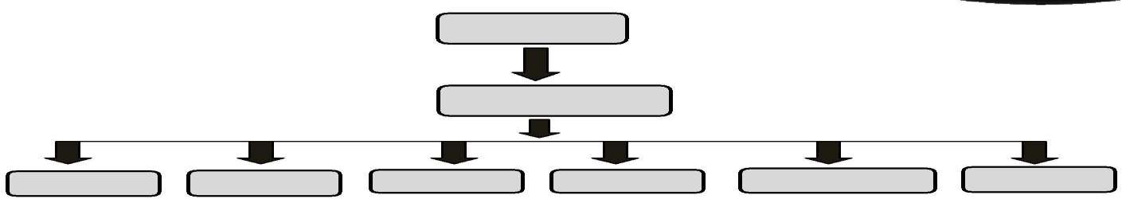
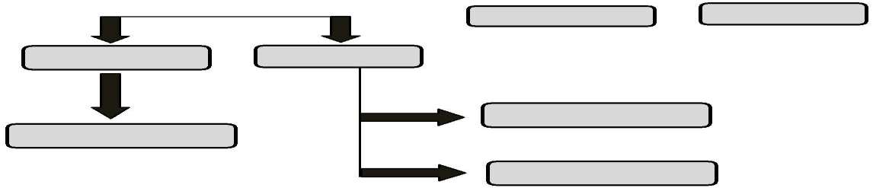

TRAINE OMCR CTL ESTATE PROCURE MIS

EB PERSON LOGISTIC

TECHNICI DIESEL

DIESEL BOY
HOUSEKEEPI

DRIVE R

ENERGY MANAGEMENT AND ASSET MANAGEMENT

For energy management there will be a specialized EB team which will monitor the electrification of sites and have a proper liaisons with SEB authority. Any electricity theft will be brought in the notice of authority immediately. (Estate team).
For asset management all the equipment will be maintained properly by carrying out PM and DI on regular basic.
All the DGs average will be taken time to time avoid misuse of diesel by the vigilance team. To safe guard the assets sites will be provided with locks and proper security.
There will be surprise checking of vehicles deployed for diesel thefts.




Telecom O& M Capabilities

R.D. TECH INFRA has qualified engineers who have carried out various OEM activities. These Engineers with the help of subcontracting teams are capable of works related with OEM e.g-

- O&M Support for BTS (GSM/CDMA) & Ancillaries
- O&M Support for MW & Ancillaries
- O&M Support for BSC / XCDR & Ancillaries
- O&M Support for MSC
- O&M Support of Fire Fighting
Implementation Methodology
Deployment of key personnel:

For any assigned project we deploy the key personnel as under to insure completion of the work with utmost perfection:-

- Project Manager - Project Manager will be responsible for overall co- ordination and monitoring the day-to-day activities at the site.
- Team Leader - The Team Leader will control and co-ordinate the activities of all technical personnel involved at
Security site. He will be responsible for providing periodical reports and feedback to the project manager.
- Co-Ordinators - The co-ordinator shall coordinate the proper collection of data’s from the site for onward information.
- Engineers - Qualified Engineers are detailed at the site to supervise the quality of Security as per the specification.

- Technicians - Team of electrical and mechanical technicians are detailed at the site to work under the supervision of site engineers.





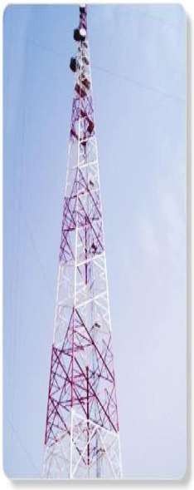
Test and Measuring Tools

R.D. TECH INFRA

Have the following Tools to execute the Site Infrastructure and telecom equipment works:

- SITE MASTER

- BIRD 800

- POWER METER

- LAPTOP

- THEODOLITE

- BER METER

- MULTI METERS

- J.C.B

- BLOWING MACHINE

- SPLICING EQUIPMENT

- HDD MACHINE

- SAFETY DEVICES




QUALITY POLICY:
R.D. TECH INFRA & Company committed to best practices in the business of infrastructure development with emphasis on completing projects on time and ensuring value for money to the nation.

The organization seeks rapid financial growth and continual improvement in its laid down objectives.

R.D. TECH INFRA
SANTOSH KUMAR PANDEY PROPRIETOR

Mobile N0. 7526004610
Corporate Office:

P R E S E N T A T I O N T I T L E
16
M E E T O U R T E A M

Shivendra Pandey
(CA) 7571004610
Shivendrardfinance@gmail.co
m
CO-founder & chief finance head

Basant Yadav B-tech (ME) 8707408042
yadavrdqlty@gmail.com
Circles head Quality UP-E

Prabhakar Singh Diploma & B-tech (CE) 7398297325
prabhakarrdmgr@gmail.com
Project Manager

Manaswi V.Chaturvedi Diploma & B-tech (CSE 7355973313
chaturvedirdhr@gmail.co
mVHR

P R E S E N T A T I O N T I T L E
17
M E E T O U R E X T E N D E D T E A M

Santosh Pandey
Managing Director
Shivendra Pandey
Co-founder &Cheif finance head
Basant Yadav
Quallity Circle Head UP-E

Prabhakar Singh
Project Manager
Manaswi Chaturvedi
HR

18

S U M M A R Y

At Contoso, we believe in giving 110%. By using our next-generation data architecture, we help organizations virtually manage agile workflows. We thrive because of our market knowledge and great team behind our product. As our CEO says, "Efficiencies will come from proactively transforming how we do business."
P R E S E N T A T I O N T I T L E

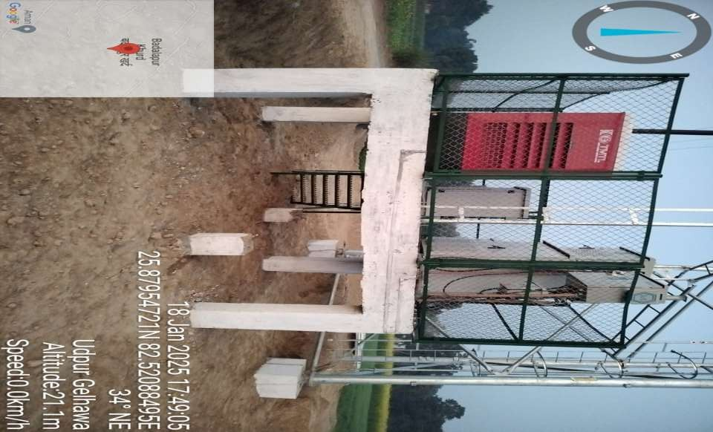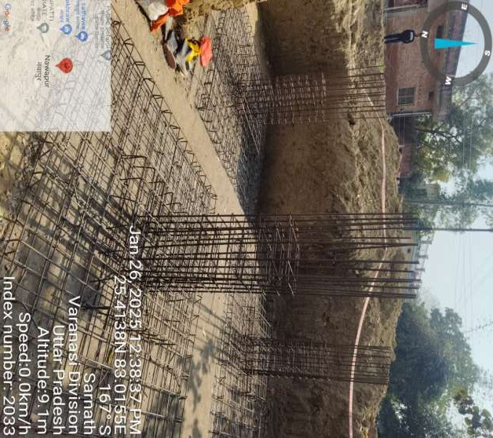

19 P R E S E N T A T I O N T I T L E

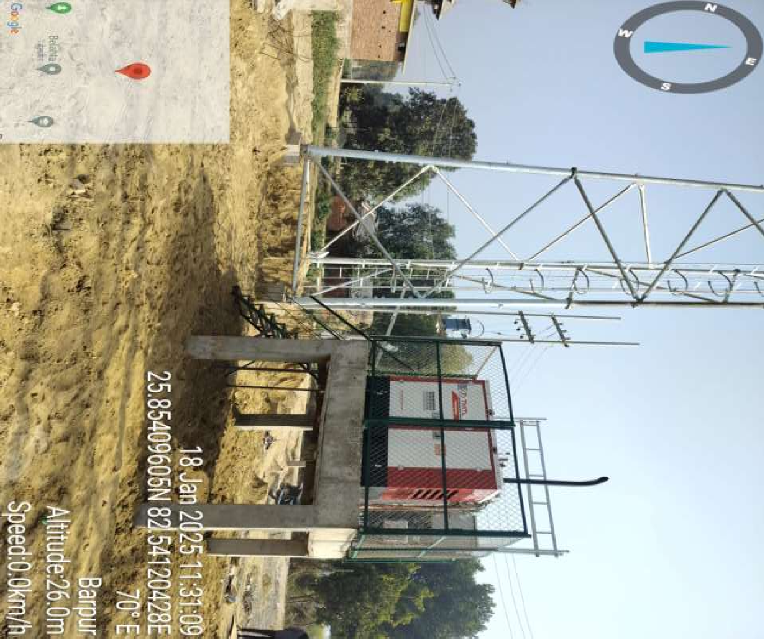
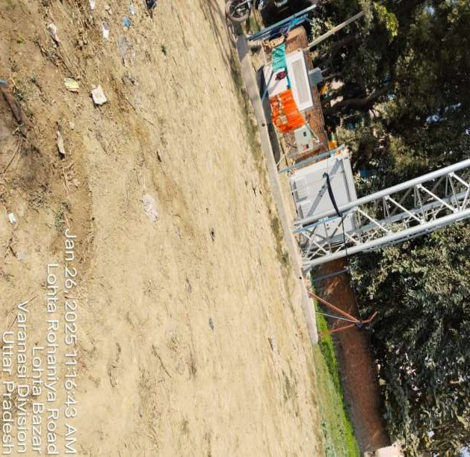

20 P R E S E N T A T I O N T I T L E

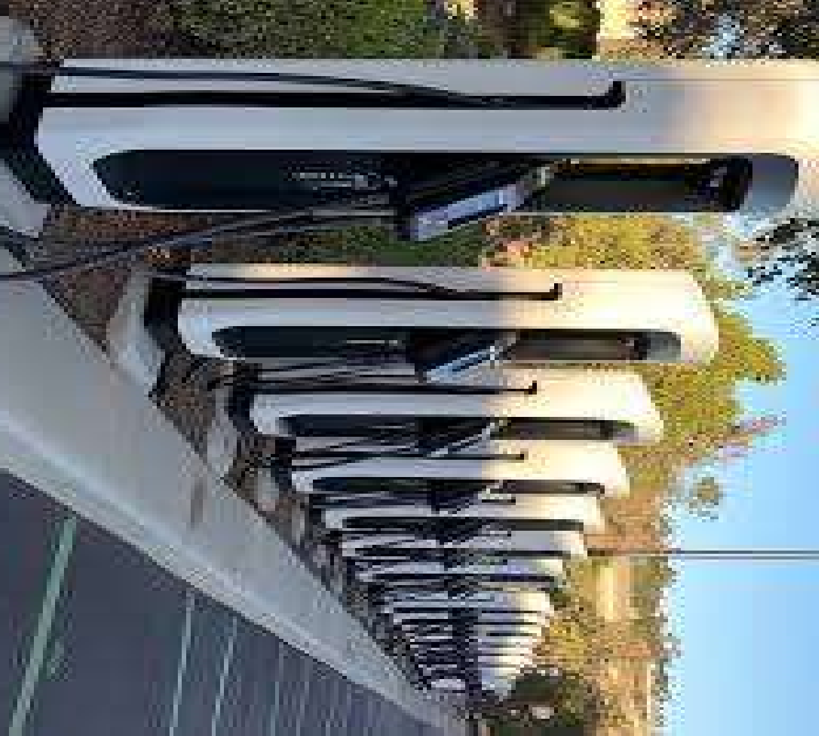
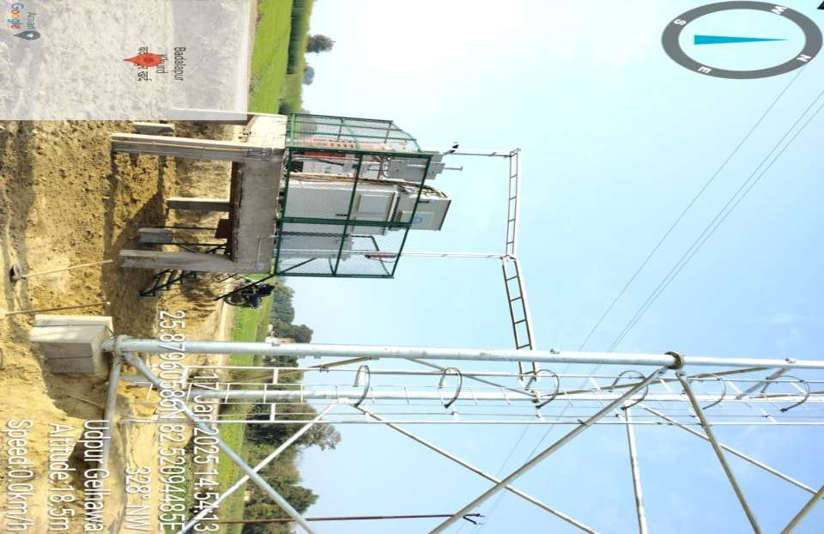

21 P R E S E N T A T I O N T I T L E


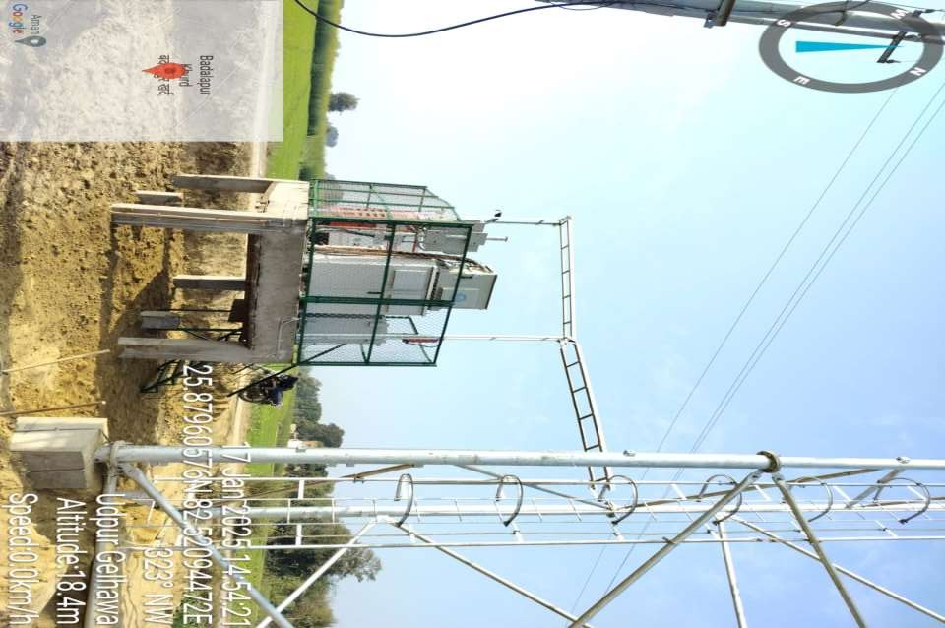

22 P R E S E N T A T I O N T I T L E

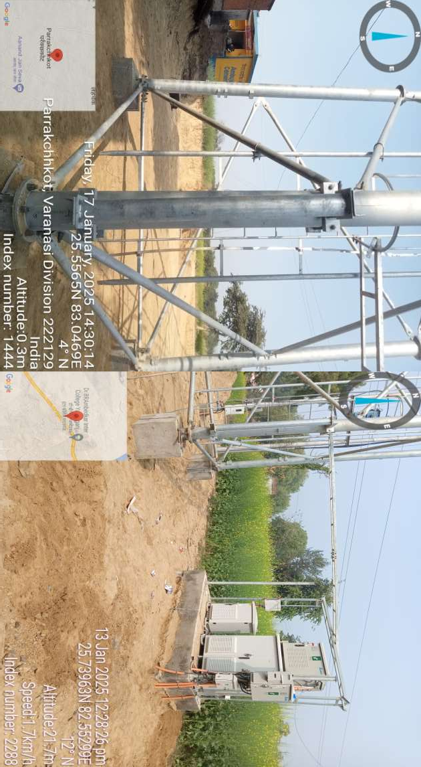

23 P R E S E N T A T I O N T I T L E

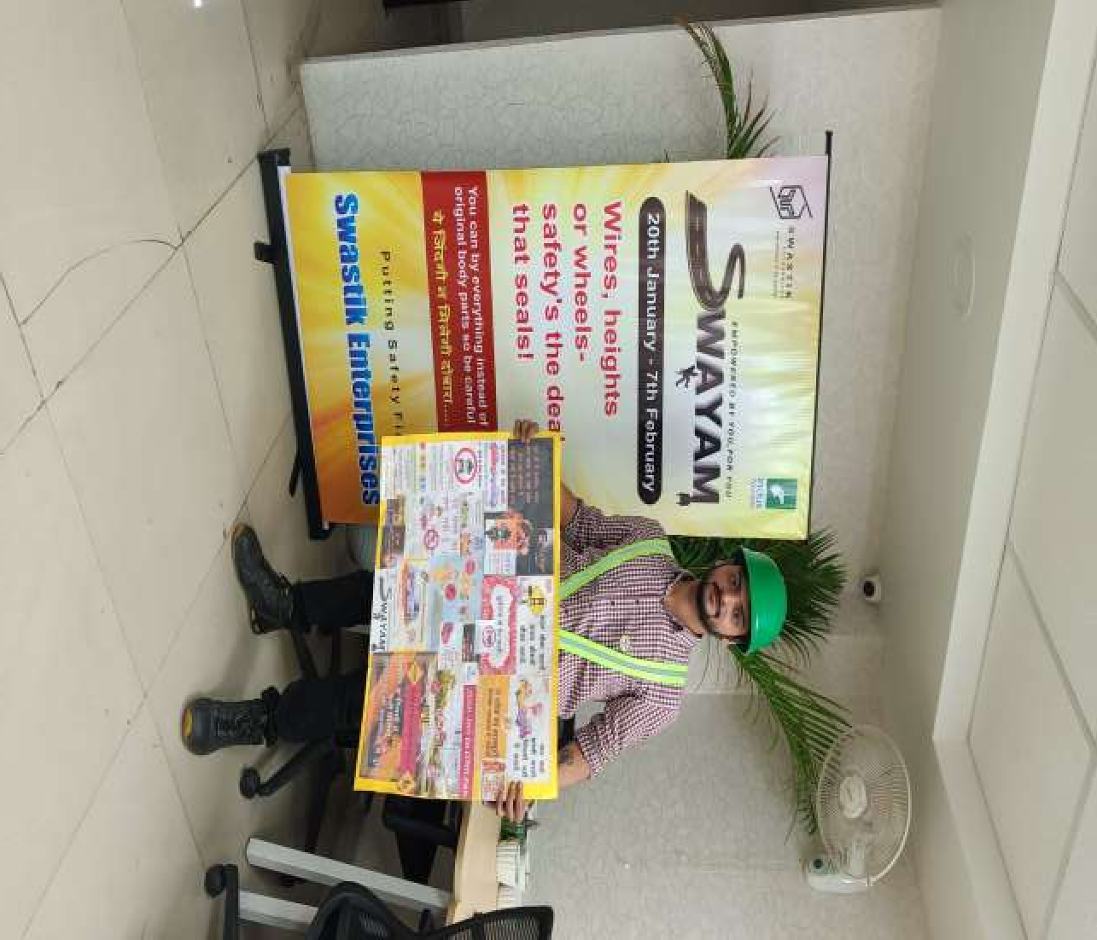
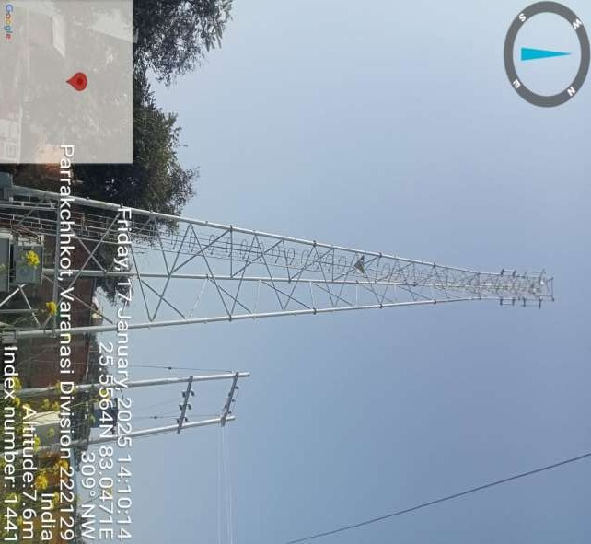

24 P R E S E N T A T I O N T I T L E

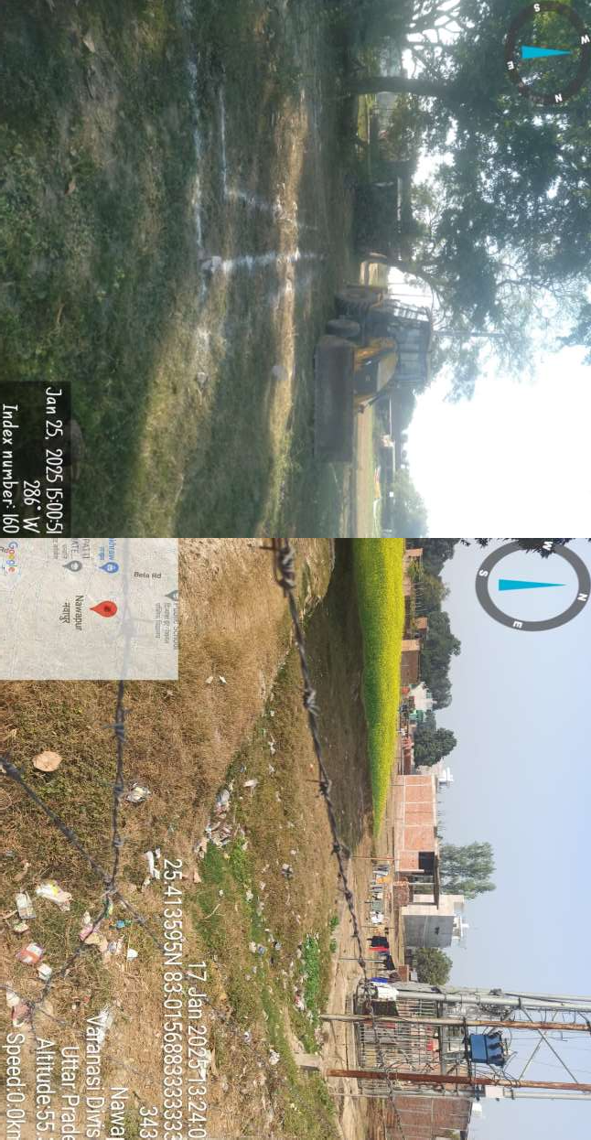

25 P R E S E N T A T I O N T I T L E

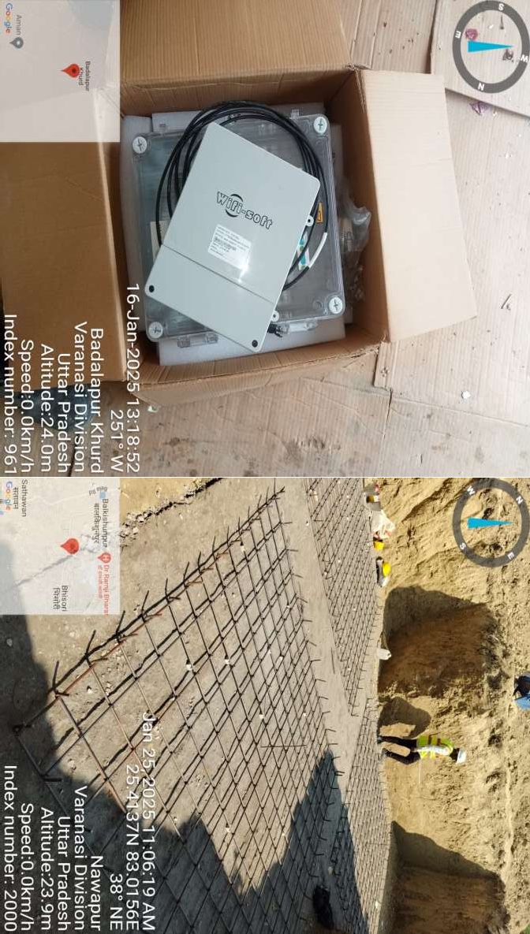

26 P R E S E N T A T I O N T I T L E


P R E S E N T A T I O N T I T L E
27

T H A N K YO U
R.D. TECH INFRA

